BONNEVILLE DAM

FISHWAY STATUS

ANNUAL REPORT

For

2003

By

Tammy M. Mackey
Timothy J. Darland
Jonathan G. Rerecich

U. S. Army Corps of Engineers
CENWP-OP-B
Bonneville Lock & Dam
Cascade Locks, OR 97014
(541) 374-4552

31 December 2003
TABLE OF CONTENTS

INTRODUCTION-----------------------------------------------------------------------------------3
Figure 1. Bonneville Lock and Dam--------------------------------------3

FISHWAY OPERATION AND ACTIVITIES-------------------------------------------------4
Fish Passage Plan (FPP) Violations-----------------------------------------------4
STS/VBS Inspections-------------------------------------------------------------------5
Table 1. STS and VBS Inspections 2002-2003-----------------------------5
Zebra Mussels-----------------------------------------------------------------------------5
Adult Fishway Temperature Monitoring------------------------------------------6
Table 2. Average temperature in the Bradford Island fishway---------6
Table 3. Average temperature in the Washington Shore fishway-----6
Table 4. Maximum temperature in the Adult Fish Facility---------------6
Fish counts---------------------------------------------------------------------------------7
Table 5. Fish passage at Bonneville Dam for 2003-----------------------7
Auxiliary Water System (AWS) Closures----------------------------------------7
Fish Unit Outages------------------------------------------------------------------------8

FISH FACILITY AND TURBINE OUTAGES------------------------------------------------8
Fish Facility Outages & Maintenance---------------------------------------------8
Turbine Outages and Dewaterings (outages of at least 24 hours)------8

FISH REMOVAL------------------------------------------------------------------------------------9

GLOSSARY----------------------------------------------------------------------------------------11

REFERENCES------------------------------------------------------------------------------------12

Acronyms and jargon are used freely in this report. The reader can find definitions in the glossary.

INTRODUCTION
This document summarizes activities impacting fish at Bonneville Lock & Dam from 1 December 2002 through 30 November 2003.

Primarily a summary of weekly reports, this document is required by the Corps of Engineers’ North Pacific Division, as described in the Fish Passage Plan (FPP). The FPP contains the following surveillance and reporting requirements. “Project biologists shall inspect fish passage facilities at the frequencies listed in the juvenile and adult fish facilities operating criteria sections. The (weekly) reports shall include: any out of criteria situations observed and subsequent corrective actions taken; equipment malfunctions, breakdowns or damage, along with a summary of resulting repair activities; adult fish control calibrations; STS and VBS inspection; any unusual activities which occurred at the project which may affect fish passage.”

The Project includes two powerhouses, a spillway and two navigation locks. The older of the two navigation locks has not operated since early 1993. There are four adult fish ladders, for upstream migration, located at each powerhouse and the north and south ends of the spillway. There are three Juvenile Bypass Systems (JBS) for downstream migration, one downstream migration transportation channel (DSM) at each powerhouse and the corner collector (scheduled to come online in March 2004) at PH2.

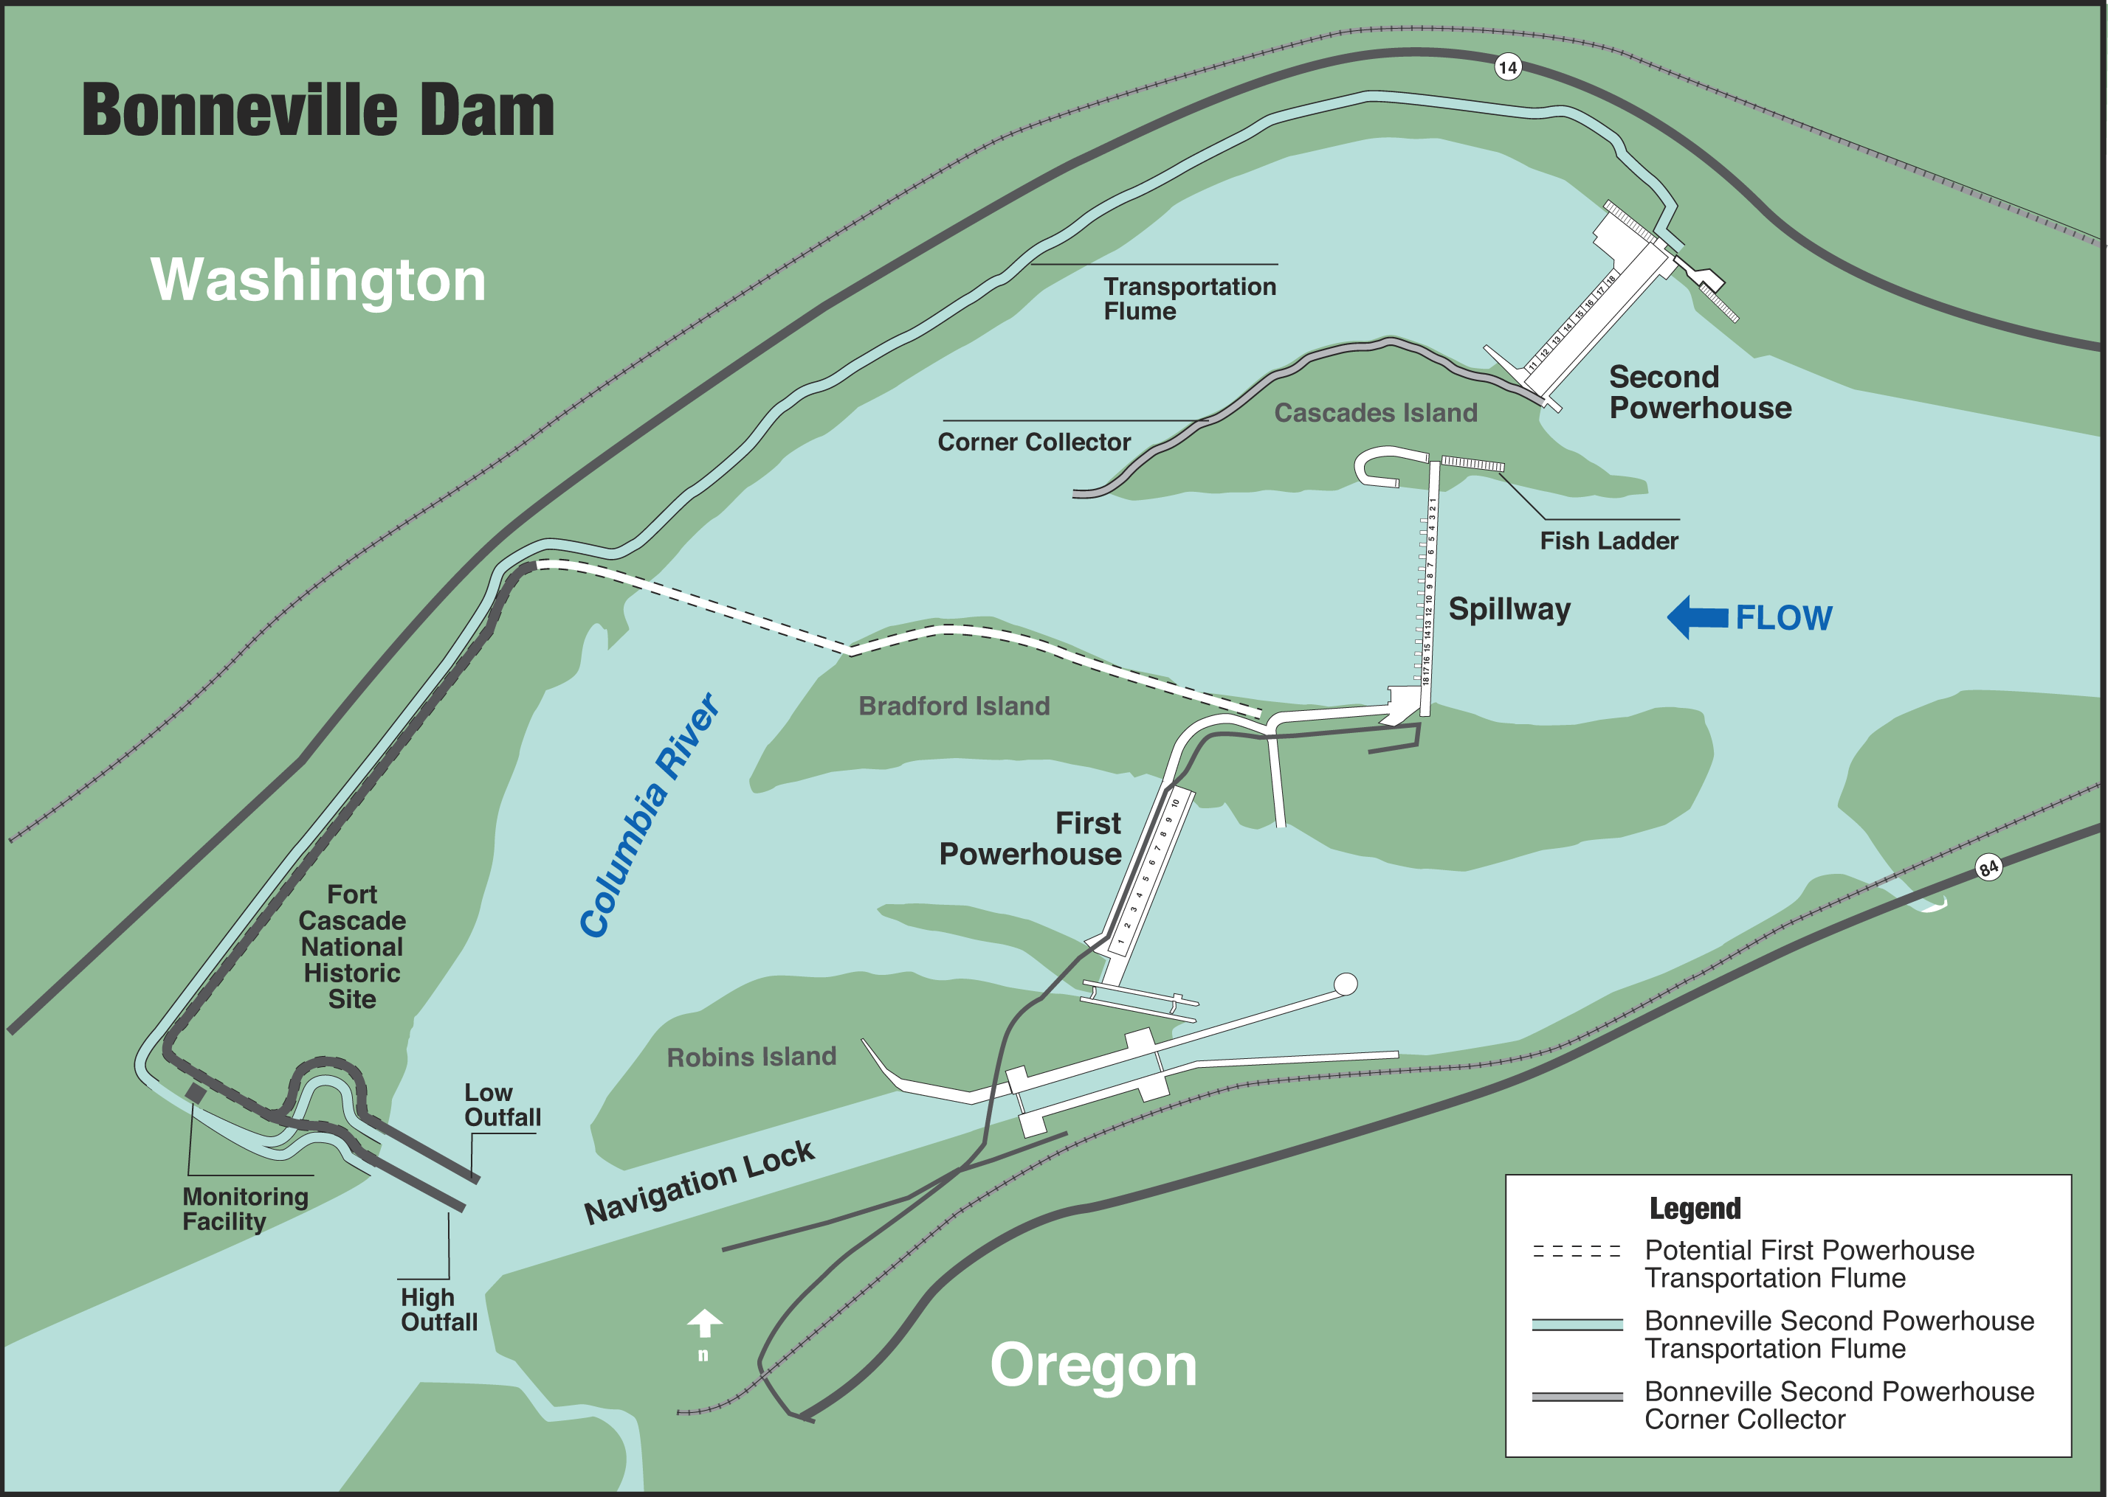

Figure 1 Bonneville Lock & Dam.

FISHWAY OPERATION AND ACTIVITIES
Fish Passage Plan (FPP) Violations

The results of 330 daily fishway inspections (seven of which were conducted by NMFS or FPC) are shown in the following table. Project Fisheries and the control room conduct inspections each day. Shown are the FPP violations, numbers of days the violation occurred, and the percentage of days the item was IN criteria.

The velocity meters were out of service or out of criteria most of the year. At PH1, the low velocities are due to an eddy is the slowest part of the collection channel. At PH2, the meter had a broken cable then had a failure with the logic board. Repairs and installation were completed by mid-November.
Chain gates were out of FPP criteria during the early months of the PH1 crane rail construction.
FG3-3 and FG3-4 were out of criteria due to a mechanical failure of FG3-3. FG3-4 was used to compensate for FG3-3.
Weir 37 was out of criteria mostly during August and September. The water levels were both over and under FPP criteria. AFF operations and fish blocking the weir drain were the primary causes for being out of criteria.
Gull Lines were down throughout most of the winter. Repairs were made in the spring by USDA.

STS/VBS Inspections

The FPP requires submersible traveling screen (STS) inspections be conducted monthly and vertical barrier screen (VBS) inspections once every two months. Each STS has a timer that automatically shows elapsed time of operation, allowing STS inspection frequency to be measured by run time. The equivalent of one month of continuous operating time is 720 hours. Bonneville inspects both STS and VBS with an underwater video camera. Video allows STSs and VBSs to be inspected simultaneously, and eliminates the need to dip gatewells or handle fish.

Table 1. STS and VBS Inspections 2002-2003

Zebra Mussels

Through weekly inspections of the monitoring station at the First Powerhouse and of all dewatered fishways, we have found no indication of zebra mussel colonization. It is understood that their arrival is inevitable. We continue monitoring with hopes that control programs can be initiated at the first indication of the zebra mussel’s arrival in the Pacific Northwest.

Adult Fishway Temperature Monitoring

Project biologists monitor fishway temperatures throughout the fish passage season and the AFF primarily during the summer months. The following temperature charts illustrate temperatures throughout the fish season. Detailed daily temperatures can be found in our weekly reports.

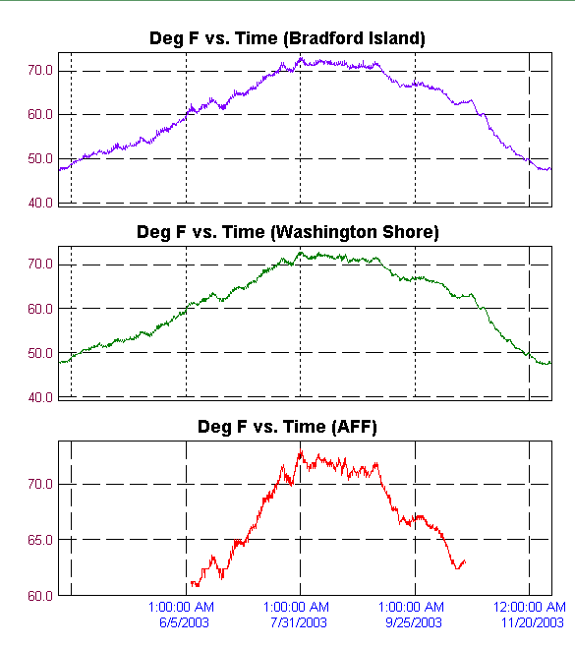
Table 2. Average Temperature in the Bradford Island fishway.
Table 3. Average Temperature in the Washington Shore fishway.
Table 4. Maximum Temperature in the Adult Fish Facility.

Fish counts

WDFW undertakes the fish counting for all fish passing by the Washington Shore and Bradford Island fishways. From March until November, there are fish counters visually counting fish for 16 hours. From November until March, counts are video taped for 16 hours. Nighttime counts were discontinued due to cost and lack of need for the data. The following chart gives an idea of our passage numbers and peak passage times.

Table 5. Fish passage at Bonneville Dam for 2003

Auxiliary Water System (AWS) Closures

The AWSs were closed for trashrack cleaning on several occasions during the 2002-2003 reporting year. Closures ranged from eight minutes to over three hours with an average closure lasting 44 minutes. AWS trashracks were usually cleaned once each month with more frequent cleanings during late summer and early fall. This year FV3-9 had 36 closures with an average of 24 minutes per cleaning. FV3-7 had 13 closures with an average closure time of 50 minutes. FV1-1 was closed 32 times with an average closure lasting 50 minutes. Mid season dives and ladder outages are not included in cleaning closure times.

FV4-3, FV4-4, FV5-3 and FV5-4 were closed an average of three and a half hours to facilitate mid-season fishway inspection dives.

Fish Unit Outages

01 Nov 02 – 15 Apr 03 F1 OOS for overhaul and stator rewind.
02 Jun 03 – 02 Jun 03 F1 OOS for trashrack raking.
06 Jun 03 – 06 Jun 03 F1 OOS for an emergency shutdown.
11 Jul 03 – 12 Jul 03 F1 OOS for vibration testing.
21 Jul 03 – 21 Jul 03 F1 OOS for mid season fishway dives at PH2.
17 Aug 03 -- 17 Aug 03 F1 OOS for unknown cause.
27 Aug 03 -- 27 Aug 03 F1 OOS for governor work.
28 Aug 03 -- 28 Aug 03 F1 OOS for governor work.
22 Sep 03 – 22 Sep 03 F1 OOS for electrical modifications.
22 Nov 03 -- 23 Nov 03 F1 OOS for field flash contactor repairs.

13 Dec 02 – 13 Dec 02 F2 OOS for transformer repairs.
16 Dec 02 – 18 Jan 03 F2 OOS for winter maintenance.
27 Jan 03 – 27 Jan 03 F2 OOS for WA Shore collection channel inspection dive.
02 Jun 03 -- 02 Jun 03 F2 OOS for trashrack raking.
21 Jul 03 -- 21 Jul 03 F2 OOS for mid season fishway dives at PH2.
23 Sep 03 -- 23 Sep 03 F2 OOS for electrical modifications.

Fish units 1 and 2 were placed on standby at other times during the year to “float” trash away from the trash racks. When drawdown measured one foot or greater, fish units were shut down. An adjacent unit was then operated to pull trash away from the fish unit trashracks. This procedure helped prevent debris and silt from accumulating in front of the fish units. Most of the unit outages associated with the floating of trash and debris occurred between midnight and 0300 to minimize impact on adult fish passage.

FISH FACILITY AND TURBINE OUTAGES Fish Facility Outages & Maintenance

29 Jul 02 – 24 Mar 03 DSM1 turned south for winter maintenance.
25 Nov 02---04 Feb 03 AFF OOS for winter maintenance and modifications.
01 Dec 02—18 Jan 03 Washington Shore fishway OOS for winter maintenance.
01 Dec 02 – 10 Mar 03 Washington Shore South Monolith for B2CC construction.
16 Dec 02 -- 28 Jan 03 Cascades Island fishway OOS for winter maintenance.
18 Dec 02 – 06 Feb 03 DSM2 OOS for winter maintenance.
01 Feb 03 – 26 Feb 03 Bradford Island fishway OOS for winter maintenance.
02 Mar 03 – 10 Mar 03 DSM2 OOS due to debris jam in the bypass flume.
27 Mar 03 -- 27 Mar 03 SMF PDS OOS for three way gate repairs.
09 Apr 03 – 10 Apr 03 DSM1 OOS for small screen sweep maintenance.
14 May 03 – 14 May 03 AFF OOS for brail pool modifications.
10 Nov 03 – present DSM1 turned south due to equipment failure, remains south for the winter.

Turbine Outages and Dewaterings (outages of at least 24 hours)

date out date in unit reason for outage
10-Jun-02 present 1 Turbine rehab
3-Sep-02 3-Dec-02 9 overhaul
23-Sep-02 3-Dec-02 8 PH1 crane rail work
23-Sep-02 30-Nov-02 10 PH1 crane rail work
30-Sep-02 3-Dec-02 7 PH1 crane rail work
7-Oct-02 6-Feb-03 16 four year overhaul
10-Dec-02 11-Dec-02 7 PH1 crane rail work/ fyke net removal
10-Dec-02 11-Dec-02 8 PH1 crane rail work/ fyke net removal
10-Dec-02 11-Dec-02 9 PH1 crane rail work/ fyke net removal
10-Dec-02 11-Dec-02 10 PH1 crane rail work/ fyke net removal
24-Feb-03 25-Feb-03 2 Servo shaft work
24-Feb-03 25-Feb-03 12 B2 Corner Collector dive operations
22-Mar-03 24-Mar-03 17 speed adjuster failure
30-Mar-03 31-Mar-03 15 emergency shutdown- exciter limit & power alarms.
14-Apr-03 15-Apr-03 15 forced outage- brake trouble
17-Apr-03 24-Apr-03 15 exciter trouble
23-Apr-03 26-Apr-03 14 remove power supply for U15
26-Apr-03 21-May-03 15 governor/ exciter work
27-Apr-03 28-Apr-03 16 STS repair
21-May-03 2-Jun-03 14 exciter power supply moved to U15
10-Jun-03 11-Jun-03 8 ESBS repair
13-Jun-03 25-Jun-03 15 Broken restoring cable
10-Jul-03 17-Jul-03 9 Headgate delivery
14-Jul-03 17-Jul-03 7 headgate removal
14-Jul-03 17-Jul-00 8 headgate removal
14-Jul-03 17-Jul-03 10 headgate removal
21-Jul-03 22-Jul-03 15 bearing oil leak
28-Jul-03 30-Oct-03 14 five year overhaul
30-Jul-03 30-Oct-03 7 five year overhaul
3-Aug-03 29-Oct-03 5 Bank 5/6 outage. Crane rail replacement
3-Aug-03 27-Oct-03 6 Bank 5/6 outage. Crane rail replacement
3-Aug-03 27-Oct-03 8 Bank 5/6 outage. Crane rail replacement
6-Aug-03 present 2 Crane rail replacement
6-Aug-03 present 3 Crane rail replacement
6-Aug-03 present 4 Crane rail replacement
19-Aug-03 21-Aug-03 12 Servo oil repair
6-Oct-03 7-Oct-03 16 tighten Kaplan piping.
17-Oct-03 present 11 emergency shutdown- exciter failure.
9-Nov-03 13-Nov-03 8 ESBS repair
17-Nov-03 18-Nov-03 14 Servo oil repair
27-Nov-03 present 10 exciter trouble

Fish Removal
Fish passage facilities and turbine units are taken out of service and dewatered to allow for inspection, preventative maintenance, repairs, and modifications. As facilities and turbine units are dewatered, project biologists, outside agency personnel, and other project personnel follow procedures outlined in the FPP and detailed in the Fish Salvage Plan to minimize impacts on fish. Fish recovered are typically released into the forebay above the new navlock, however, sturgeon and juvenile salmonids are released below the dam at Hamilton Island.
The following is a summary of the number of fish removed during facility and turbine unit dewaterings. All fish were recovered in good condition unless otherwise noted.
UMT (12-03-02): one crayfish, five sculpin, 41 adult steelhead (one dead), 20 resident fish.

Washington Shore (12-03-02): 200-300 lamprey, 12 sculpin, one steelhead.

Cascade Island AWS (12-16-02): 200 residents, one juvenile chinook, one steelhead jack.
Cascade Island diffuser pools (12-16-02): 22 steelhead, one coho, 18 residents.
Cascade Island entrance (12-17-02: seven lamprey, 12 whitefish, one sculpin, two crawfish.

UMT (12-18-02): 15 lamprey, three sticklebacks, two sculpin.

DSM2 (12-18-02): one adult steelhead.

Unit 16 tail logs (01-29-03): six sculpin, two channel catfish

Bradford Island (BI) ladder (02-03-03): 33 lamprey, 20 adult steelhead, 18 juvenile steelhead, 11
sculpin, six juvenile chinook, 20 resident fish, one stickleback, two suckers, one peamouth
BI junction pool (02-03-03): four unknown adult steelhead, 16 clipped adult steelhead, 17
unclipped adult steelhead, 20 juvenile steelhead, four juvenile chinook, one chinook fry, 27 chubs/peamouth, 12 whitefish, one stickleback
BI A-Branch (02-03-03): two adult steelhead, three crawfish, three sculpin, two chubs.
BI B-Branch (02-03/04-03): one unknown adult steelhead, one clipped adult steelhead,
approximately 30 chubs, three sculpin
B-Branch entrance pool (02-04-03): six juvenile chinook, one clipped juvenile steelhead, one
lamprey

A-Branch diffuser pool (02-11-03): two clipped adult steelhead.

Bradford Island exit (02-19-03): one crayfish, three sculpin and four chubs.

Smolt Monitoring Facility bypass flume (03-02-03): 25 unknown adult steelhead, one adult
chinook, one juvenile chinook, two whitefish- all alive. Eight adult shad, 19 juvenile shad, two juvenile chinook, one 2-3’ sturgeon, two smelt, one stickleback- all dead.
Smolt Monitoring Facility bypass flume (03-05-03): 12 adult steelhead, one juvenile chinook- all
alive. 22 juvenile shad, six adult shad, one peamouth and one clipped adult steelhead- all dead.

DSM1 (04-10-03): ten juvenile steelhead, 20 juvenile chinook, three sculpin.

Unit 14 draft tube (07-29-03): 16 sturgeon (two dead), nine channel cats, one rainbow, two dead
shad.
Unit 14 scroll case (07-29-03): approximately 40 dead shad.

Unit 7 draft tube (07-31-03): seven sturgeon (two dead), three lamprey, one channel cat.
Unit 7 scroll case (09-24-03): one lamprey.

GLOSSARY
AFF----- Adult Fish Facility. Lab associated with the Washington Shore ladder. Adult fish are trapped for research purposes.
B2CC---- Powerhouse Two Corner Collector. A surface bypass system located in the southern corner of the Bonneville Second Powerhouse forebay. The corner collector was completed in 2003 and will be ready for operation during the 2004 fish passage season.
BiOp Biological Opinion.
BON Bonneville Lock & Dam.
Downwell Opening through which water and fish drop after excess water is drawn away through a dewatering screen. Start of the transport conduit for fish from DSM1 to the tailrace.
DSM 1-- Downstream Migrant transportation channel (PH1). Transport channel for juvenile fish from gatewell orifices to the downwell.
DSM 2-- Downstream Migrant transportation channel (PH2). Transport channel for juvenile fish from gatewell orifices to the juvenile transport pipe.
CRITFC Columbia River Intertribal Fish Commission.
FFU----- Fisheries Field Unit. Unit in the Corps of Engineers’ Portland District Construction, Operations Division that conducts fish related evaluations and monitoring.
Forebay That area of a reservoir immediately upstream of a dam.
FPC Fish Passage Center.
FPP Fish Passage Plan.
JBS Juvenile Fish Bypass System. Usually refers to PH2.
Kcfs Thousand cubic feet per second.
NDE----- North Downstream Entrance. Refers to one of the four large overflow weir adult fishway entrances at PH2.
NUE North Upstream Entrance. See NDE.
NMFS National Marine Fisheries Service. Now known as NOAA Fisheries.
ODFW Oregon Department of Fish & Wildlife
OOS Out Of Service.
PCC----- Powerhouse Collection Channel. Part of the adult fishway spanning the length of the downstream side of each powerhouse.
PH1 Bonneville First Powerhouse.
PH2 Bonneville Second Powerhouse.
PIT ------ Passive Integrated Transponder. A tag inserted into juvenile and adult fish. Detectors are installed at all fish passage systems.
Project Bonneville Lock & Dam.
SDE South Downstream Entrance. See NDE.
SMF Smolt Monitoring Facility. Lab associated with the PH2 JBS.
SUE South Upstream Entrance. See NDE.
STS Submersible Traveling Screen.
Tailwater The portion of a river immediately downstream of a dam or powerhouse.
TIE Turbine Intake Extension.
Tule Early spawning fall chinook.
UMT----- Upstream Migrant Transportation channel. This channel connects Cascades Island ladder to Washington Shore ladder through PH2.
VBS Vertical Barrier Screen.
WDFW Washington Department of Fish & Wildlife.

REFERENCES

2003. Fish Passage Plan for Corps of Engineers Projects. U. S. Army Corps of Engineers, North
Pacific Division, Portland, Oregon.

